**Unit 4 - Reading 3**

**Force Fields**

In previous discussions, we have described forces as being either contact or long range forces. **Contact forces** result from the interaction between two objects that are touching. These forces include forces of static and kinetic friction, tension forces and normal forces. **Long range** forces result from the interaction of the system with some other body through a force field such as magnetic, electric, or gravitational fields.

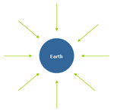

The Earth affects the space around it, creating what we call a ‘gravitational field’. The mass of the Earth attracts all other masses around it towards its center, as shown in the picture to the left. The arrows show the direction in which the force on an object will act. When we zoom in to look at this field from the surface of the Earth, the radial field lines begin to look more like parallel lines as shown below.

Close to earth we see the gravitational field as acting vertically. At common altitudes the gravitational field strength is constant. In the investigation we conducted, we determined the gravitational field strength “gfs” = 9.8 N/kg (gfs is commonly shortened to *g*). This means that, near the surface, the Earth generates a ‘uniform’ gravitational field around itself that attracts every kilogram of matter with a force of 9.8 Newtons.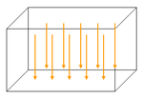

Fg = m * gfs

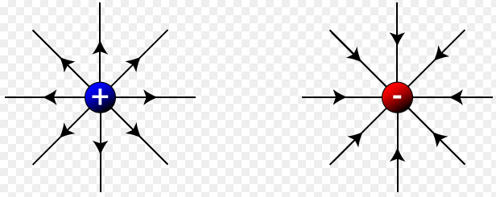Similarly, electric fields are the result of how electrically charged particles affect the space around them. Unlike gravitational fields, which are always attractive, electric fields can be attractive or repulsive depending on the electric charge of the particle it acts upon. As shown to the left, positive charges create an electric field around them that acts ‘outward’ from the positive charge, whereas the negatively charged particle creates an electric field that acts ‘inward’ (much like gravitational fields).

Charged metal plates create a uniform electric field between them. The electric field is directed from the positive plate to the negative plate. The electric field pushes a positive charge placed in this field from the positive to the negative plate. The electric field pushes a negative charge placed in the electric field from the negative to the positive plate. 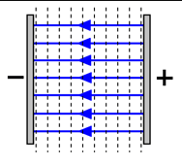

The amount of electric force on the charge is equal to the amount of the charge “q” times the electric field strength “efs”.

Fe = q * efs

In general, the force that a field (Ffield) exerts on an object is equal to the product of the matter field property (i.e. mass, electric charge, etc.) and the field strength (“gfs”, “efs”, etc.).